**Insert School Logo**

**Semester Two**

**Examination 2024**

**Question/Answer Booklet**

**PSYCHOLOGY**

**UNITS 3&4**

Name: _______________________________________________________

Teacher: ___________________________________________________

***TIME ALLOWED FOR THIS PAPER***

Reading time before commencing work: Ten minutes

Working time for the paper: Three hours

***MATERIALS REQUIRED/RECOMMENDED FOR THIS PAPER***

**To be provided by the supervisor:**

* This Question/Answer Booklet

**To be provided by the candidate:**

* Standard items: pens, pencils, eraser or correction fluid, ruler, highlighter.
* Special items: Calculators satisfying the conditions set by the SCSA for this subject.

***IMPORTANT NOTE TO CANDIDATES***

No other items may be taken into the examination room. It is **your** responsibility to ensure that you do not have any unauthorised notes or other items of a non-personal nature in the examination room. If you have any unauthorised material with you, hand it to the supervisor **before** reading any further.

**Structure of this paper**

|  |  |  |  |  |  |
| --- | --- | --- | --- | --- | --- |
| Section | Number of questions available | Number of questions to be answered | Suggested working time  (minutes) | Marks available | Percentage of exam |
| Section One  Short answer | 7 | 7 | 120 | 144 | 70 |
| Section Two:  Extended Response  Part A | 1 | 1 | 60 | 20 | 10 |
| Part B | 2 | 1 | 35 | 20 |
|  |  |  | **Total** | 199 | 100 |

**Instructions to candidates**

1. The rules for the conduct of Western Australian external examinations are detailed in the *Year 12 Information Handbook 2024.*
2. Answer the questions according to the following instructions:

Section One and Two: Write your answers in this Question/Answer booklet preferably using a blue/black pen. Do not use erasable or gel pens. Wherever possible, confine your answers the lines/spaces provided.

Section Two Part B: Consists of two questions. You must answer one question. Write your answer in this Question/Answer booklet preferably using a blue/black pen. Do not use erasable or gel pens.

1. You must be careful to confine your responses to the specific questions asked and follow any instructions that are specific to a particular question.
2. Supplementary pages for planning/continuing your answers to questions are provided at the end of this Question/Answer booklet. If you use these pages to continue and answer, indicate at the original answer where the answer is continued, i.e. give the page number.

# Section One: Short Answer 70% (144 marks)

This section has **seven** questions. Answer **all** questions. Write your answers in the space provided.

Supplementary pages for planning/continuing your answers to questions are provided at the end of the Question/Answer booklet. If you use these pages to continue an answer, indicate at the original answer where the answer is continued, ie – give the page number.

**Suggested working time** for this section is **120 minutes**.

**Question 1 (25 marks)**

New cars now have a 13-inch monitor on the dashboard that shows a GPS-map as well as notifications from linked devices like mobile phones and online streaming services. A group of psychologists are concerned that adding this monitor on the dashboard will distract drivers and blind them to what they should be focusing on the road.

a) Identify the type of attention used when driving a car. (1 mark)

b) Identify the **three** processes of perception and describe how each process would influence driving behaviour. (6 marks)

1

2

3

c) The psychologists decided to conduct an experiment to test the impact of these electronic monitors and the constant stream of information they provide on driver perception and driving performance. Snowball sampling was used to recruit one hundred 25 to 45-year-old drivers with only minor traffic infringements and had not been involved in any major accident.

i. Explain how participants are selected using snowball sampling. (2 marks)

ii. Provide **one** strength and **one** limitation of snowball sampling. (2 marks)

Strength:

Limitation:

d) Each driver drove through a 10-km road with simulated driving hazards like blind corners, intersections, an e-scooter, a motorbike, a cyclist, and a pedestrian cross their path as they were driving along. The errors they committed were counted and used to measure driver perception and driving performance. Half of the participants drove a car with only standard driving information from the dashboard such as driving speed, fuel level, and engine temperature. The other half were asked to drive a car with the standard car information on the dashboard as well as a 13-inch monitor constantly displaying GPS information, notifications from their mobile phone, news items, and their music playlist.

i. Construct a directional research hypothesis for the psychologists’ experiment. (4 marks)

ii. Identify the experimental and control conditions and state how participants should be allocated to each group. (3 marks)

Experimental condition:

Control condition:

How participants are allocated:

e) The psychologists informed participants that they were testing car performance rather than driver perception and were not aware of what type of car they would be driving prior to the driving test. Although this information was withheld, the ethics committee approved their research proposal.

Provide **two** reasons for the ethics committee’s approval to withhold this information from participants. (2 marks)

i.

ii.

|  |  |
| --- | --- |
| **Car Dashboard Description** | **Mean Number of Driving Errors Committed** |
| Standard Dashboard Information provided | 5 |
| Standard Dashboard information plus 13-in monitor displaying GPS and streamed notifications | 13 |

f) A summary of the results is given in the table below.

i. Provide a conclusion for the study based on the given results. (2 marks)

ii. Explain results of this experiment in relation to the perception process and how driver perception impacts on driving performance. (3 marks)

**Question 2** **(17 marks)**

a) Dingoes are native predators in Australia that can sometimes prey on sheep, particularly young lambs. This can cause significant economic losses for farmers. Traditional methods like fencing have not always been completely effective. Dingoes have a strong sense of smell and are especially sensitive to the smell of sheep wool. They are also known to be wary of loud noises as it startles them, activating their flight response of running away.

A farmer who took Psychology in Year 12 and knows about classical conditioning decided to develop a plan to stop dingoes from predating on his lambs using the principles of classical conditioning.

i. Specify the unconditioned stimulus (UCS) and the unconditioned response (UCR) that the farmer would focus on. (2 marks)

UCS:

UCR:

ii. Identify a neutral stimulus (NS) that the farmer can use given the information about dingoes. (1 mark)

NS:

iii. Describe how the dingoes would be made to associate the unconditioned stimulus with the neutral stimulus. (3 marks)

iv. State what the conditioned stimulus (CS) and conditioned response (CR) should be that would save the farmer’s lambs from getting eaten by dingoes. (2 marks)

CS:

CR:

v. How can the farmer ensure that his conditioning method is humane and will not harm the dingoes or other animals? Your response should identify the appropriate ethical practice when dealing with animals. (2 marks)

b) Juan was 5 years old when he was attacked by a dingo puppy when they were camping in the bush with his family. He does not have any memory of what happened but as he grew older, he found that he has an irrational fear of dogs, especially those that look like dingoes.

i. Identify the theory of forgetting that would explain why Juan does not remember being attacked. (1 mark)

ii. Provide a reason for Juan’s phobia of dogs when he was older. (1 mark)

iii. Name and describe a treatment that would help Juan overcome his phobia of dogs.

(5 marks)

**Question 3 (16 marks)**

The Numbat Project of Perth Zoo aims to reintroduce zoo-bred numbats into their natural habitat – the forests in the southwest of Western Australia. Numbats are an endangered species found exclusively in the southwest of WA with only about a thousand left in the wild. One part of the program is predator awareness where numbats learn to run and hide when they see and hear birds of prey such as owls, crows, and eagles. The zookeeper would fly kites in the shape of a bird of prey over the enclosure and/or play a recording of its bird call. If the numbat that is out in the open does not run and hide, they squirt a water pistol to direct a blast of water near the numbat to make it run and hide. When the numbat runs and hides as soon as the bird of prey shape appears above or hears the bird call, it does not get squirted.

a) Describe the **three**-phase model of operant conditioning. (6 marks)

1.

2.

3.

b) Explain how each phase of the model was applied in teaching the numbat to respond appropriately to the presence of predatory birds. (3 marks)

1.

2.

3.

c) Name the type of consequence that the squirts of water represent and explain its effect on the Numbat’s behaviour. (3 marks)

d) Zookeepers know that the best way to maintain learned behaviour is by using a *variable ratio schedule of reinforcement*. They initially tested the effectiveness of providing a variable schedule of reinforcement using a Skinner box (see Figure 1). They used the bird call sound and its favourite food (termites) to maintain the behaviour of running and hiding whenever it hears the bird call.

Burrow-like enclosure for hiding.

Food Dispenser



Figure 1. Diagram of a Skinner Box for training numbats.

i. Explain what a *variable ratio* schedule of reinforcement is. (1 mark)

ii. Describe a procedure that would test the *variable ratio schedule of reinforcement* using the scenario given above. (3 marks)

**Question 4** **(21 marks)**

a) Referring to Deci and Ryan’s Self Determination Theory, identify and outline the **three** psychological needs that influence motivation. (6 marks)

1.

2.

3.

b) Marco is struggling to stay motivated in his history class. He finds the lectures dull and sees little relevance to the material they are learning.

Apply your understanding of the psychological needs for motivation described by the Self Determination Theory (Deci and Ryan, 1985) to explain why Marco might be lacking motivation. (3 marks)

c) Elma is in the same history class as Marco and is the top student. She enjoys historical fiction novels and spends a lot of time researching historical periods related to the books she reads. She has even tried her hand at writing a historical short story.

i. Distinguish between extrinsic and intrinsic motivation. (2 marks)

ii. Explain how Elma's interest in history could be extrinsically and intrinsically motivated.

(2 marks)

d) Sami is the head baker in a bakeshop owned by a large multinational company. The company pays him competitive rates and he enjoys the teamwork and friendship in the bakeshop. He feels that the challenges in his workplace allow him to improve his baking skills and grow as a person. He takes pride in baking products that help his customers celebrate special occasions or give comfort at times of sadness. This brings him much joy and fulfillment.

i. List the first **two** *deficiency needs* in Maslow’s hierarchy of needs (1954) that must be met before any of the other needs could be met. (2 marks)

ii. Explain how Sami has met **one** of the higher deficiency needs in Maslow’s hierarchy of needs (1954) that are based on relationships he has made with others. (2 marks)

iii. Define ‘self-actualization’ according to Maslow’s theory and provide **one** piece of evidence from the scenario that shows Sami has attained self-actualization. (2 marks)

e) After a few years of working in the bakeshop, Sami finds that he feels guilty about having to dispose of baked goods at the end of the day even though they are still perfectly good to eat. The company’s policy specifies that their products are baked fresh daily, and they are not allowed to drop their prices for remaining products to facilitate sales. Sami wrote to the company executives and was able to obtain permission to donate unsold baked goods to his local charity after the bakery closes for the day.

Referring to the scenario in e) above, name and define the growth need that was not fulfilled for Sami prior to the change in company policies. (2 marks)

**Question 5** **(19 marks)**

a) Complete the description of the model of subjective wellbeing proposed by Diener (1984) by providing the missing information in the table. (3 marks)

|  |  |
| --- | --- |
| **Key component** | **Description** |
| **Affective balance** | i. ________________________________________________  __________________________________________________  __________________________________________________  __________________________________________________ |
| ii. __________________  ____________________ | **Your overall judgment about your job, relationships and life achievements.** |

b) John and Dean have lost their jobs and were given only until the end of the month to wrap up their work. John is quite depressed and does not see any future for himself, whereas Dean is starting his own business and is looking forward to getting his first order.

i. Contrast John’s and Dean’s subjective wellbeing based on Diener’s model. (6 marks)

John:

Dean:

ii. Apply Carol Ryff’s (1989) psychological wellbeing scale to the scenario given in b) by identifying **two** relevant factors in the scale and describing John’s and Dean’s response. Your description should state whether the factor is in the high or low dimension supported by the corresponding behaviour of John and Dean. (10 marks)

|  |  |
| --- | --- |
| **Psychological Wellbeing Factor 1:** | |
| John’s Dimension |  |
| John’s Behaviour |  |
| Dean’s Dimension |  |
| Dean’s Behaviour |  |

|  |  |
| --- | --- |
| **Psychological Wellbeing Factor 2:** | |
| John’s Dimension |  |
| John’s Behaviour |  |
| Dean’s Dimension |  |
| Dean’s Behaviour |  |

**Question 6 (25 marks)**

a) Provide a psychological definition of ‘*stress*’. (1 mark)

b) Hans Selye proposed a model of stress that describes the body’s response calling it the General Adaptation Syndrome (illustrated in Figure 2).

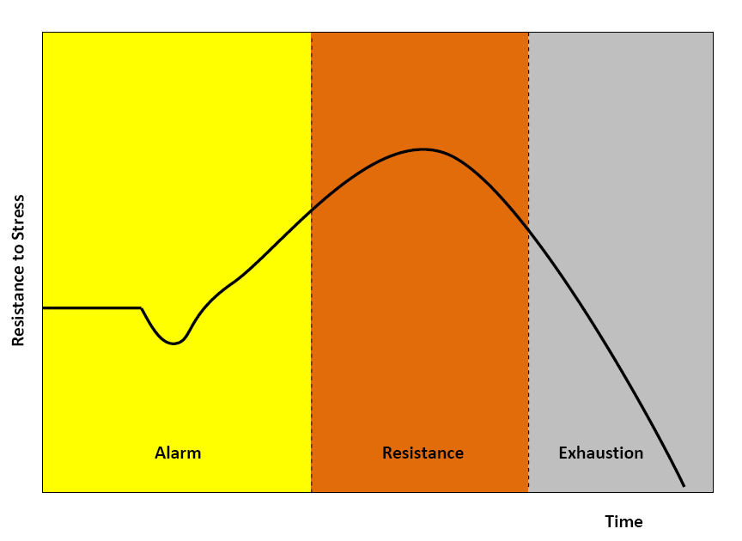

Stage 1

Stage 2

Stage 3

**Figure 2**. Stages of Selye’s general adaptation syndrome.

i. Name stages 1 and 2 of Selye's General Adaptation Syndrome and outline how the nervous system would respond in each stage. (6 marks)

1.

2.

ii. Name stage 3 of Selye’s General Adaptation Syndrome and describe a psychological response that would be present in this stage. (2 marks)

c) Lev is taking six ATAR subjects in Year 12. He was coping very well in Year 11 with the same six subjects, so he decided to continue with it in Year 12. He had a study schedule and was staying on task in the first term, but he found that he seems to catch colds and other minor infections easily. He got really sick at the end of Year 12 and his doctor found he has high blood pressure.

Distinguish between ‘*distress*’ and ‘*eustress*’. Provide an example of each referring to the description of Lev’s experiences in Years 11 and 12. (4 marks)

d) Bijit is a medical intern in the emergency department of a major hospital who worked on the frontline throughout the COVID-19 pandemic. He witnessed the overwhelming effects of the virus firsthand and experienced long shifts with limited resources. This situation caused a lot of stress, and he experienced high levels of anxiety.

Refer to the Transactional Theory of Stress and Coping (Lazarus and Folkman, 1984) when answering the following questions:

i. Explain how Bijit’s individual characteristics, and his work environment contributed to his stress experience. (2 marks)

ii. Outline the process of cognitive appraisal that Bijit would have gone through in this situation. (4 marks)

iii. Give an example of an emotion-focused and a problem-focused coping strategy that Bijit could employ to manage his stress. State how each strategy would be beneficial to his wellbeing. (4 marks)

Emotion focused coping strategy:

Benefit:

Problem-focused coping strategy:

Benefit:

iv. Briefly explain why relying on a single coping strategy might not be sufficient for Bijit.

(2 marks)

**Question 7 (21 marks)**

a) Describe an evolutionary and a restorative function of sleep. (2 marks)

Evolutionary function:

Restorative function:

b) Identify the stage of NREM sleep designated by the brainwave patterns given below.

(3 marks)

|  |  |
| --- | --- |
| **Brainwave pattern** | **Stage of NREM Sleep** |
| **A.** |  |
| **B.** |  |
| **C.** |  |

c) State the letter of the brainwave pattern (A, B or C) illustrated in the table above that would occur when breathing is regular, but pulse rate and blood pressure are at its lowest; muscles are at their most relaxed state, and one is unresponsive to external stimuli. (1 mark)

d) Apart from rapid eye movement, state **two** other features of REM sleep that are different from NREM sleep. (2 marks)

e) Provide **one** psychological and **one** physiological effect of partial and chronic sleep deprivation. (4 marks)

|  |  |  |
| --- | --- | --- |
|  | **Psychological Effect** | **Physiological Effect** |
| **Partial sleep deprivation** |  |  |
| **Chronic sleep deprivation** |  |  |

f) A longitudinal study of the sleep patterns of 6,500 Australian children and adolescents was conducted between 2010-2016. Sleep patterns of children between 6 to 9 years old were obtained from self-report questionnaires answered by their parents or legal guardians while 10 to 17-year-olds responded to the questionnaires themselves.

i. State **one** advantage and **one** disadvantage of conducting a longitudinal study in this sleep study. (2 marks)

ii. Describe **one** limitation of using self-report questionnaires for obtaining sleep data.

(1 mark)

iii. Suggest **one** type of quantitative data that uses an objective physiological measure which researchers should include in their longitudinal sleep study. (1 mark)

The average sleep duration of children and adolescents are shown in Figure 3.

Age Group

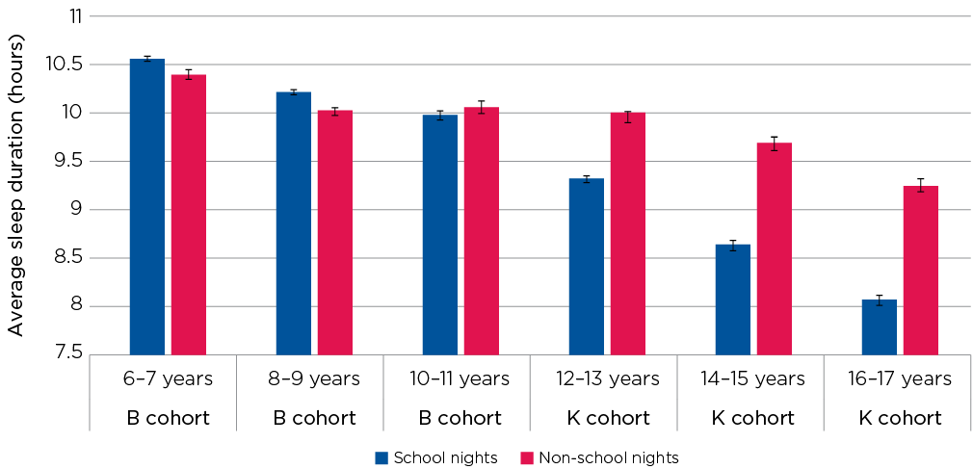

n School night

~~n~~ Non-school night

**Figure 3**. Average sleep duration in hours, by age. (Reproduced from Evans-Whipp and Gasser, 2019)

iv. Referring to Figure 3, compare the sleep duration patterns on school nights and non-school nights of primary school children (6 to 11 years old) and adolescents in high school (12 to 17 years old). (2 marks)

This sleep study also found that 50% of 16 to 17-year-olds do not meet the minimum sleep guidelines on school nights. A key factor that had a negative impact on sleep patterns is the use of electronic devices before bedtime.

v. Suggest **two** ways that 16 to 17-year-olds can minimize the negative impact of electronic devices on sleep hygiene. (2 marks)

vi. The researchers measured the psychological wellbeing of 16 to 17-year-old participants and found a positive correlation between sleep duration and psychological wellbeing.

State what a ‘*positive correlation*’ between sleep duration and psychological wellbeing scores means. (1 mark)

**End of Section One**

# Section Two: Extended Response 30% (55 marks)

This section has **two** parts. You must answer **one** question in Part A and **one** question in Part B.

**Part A:** This part has **one** compulsory question. Write your answer in the space provided.

**Part B:** Answer **one** question from a choice of **two.** Write your answer in the space provided.

Supplementary pages for planning/continuing your answers to questions are provided at the end of this Question/Answer booklet. If you use these pages to continue an answer, indicate at the original answer where the answer is continued, i.e. give the page number.

**Recommended working time** for this section is **60 minutes**.

______________________________________________________________________________

**Part A:** This part has **one** compulsory question. Write your answer to Part A Question 8 on pages 25-29.

**Part B:** Select **either** Question 9 on page 30 **or** Question 10 on page 31. Write your answer to Part B on pages 32-38. You must include the number of the question you are answering at the start of your answer.

______________________________________________________________________________

**Question 8** **(20 marks)**

Yohan is a 65-year-old retired carpenter who had been a heavy drinker for most of his adult life. His wife passed away a year ago and in recent months, his drinking has become excessive. His daughter, Sal, has become increasingly concerned about his forgetfulness. Yohan frequently asks the same questions repeatedly, like where he put his keys or if Sal has visited recently (even if she just left). He seems confused about current events and insists he's going to work, despite being retired a few years. One day, Sal finds Yohan disoriented and visibly upset in the kitchen, fumbling with a pan and a lit stove. He had no recollection of starting to cook. Worried, she takes him to the doctor where she learns that Yohan is suffering from Wernicke-Korsakoff syndrome.

Sal is 35 years old, has no children and had gone through a divorce a few years before her mother (Yohan’s wife) died. She is now the primary caregiver for her father. Yohan requires constant supervision due to confusion and memory problems. Sal struggles to manage her full-time job, household chores, and Yohan's care, leaving her feeling exhausted and overwhelmed.

Apply your psychological understandings of Wernicke-Korsakoff syndrome and the Social Readjustment Scale (SRS) of Holmes and Rahe (1967) to evaluate the psychological impact of stressors on Sal’s health and wellbeing. Your extended response should:

* Describe the cause of memory loss in Wernicke-Korsakoff syndrome. (3 marks)
* Provide examples from the scenario that shows the behavioural and emotional effects of Wernicke-Korsakoff syndrome. (2 marks)
* Identify **three** life events from the Social Readjustment Scale (SRS) of Holmes and Rahe (1967) that could be relevant to Sal's situation and explain how each life event would relate to the challenges of caring for Yohan. (6 marks)
* State **two** potential negative consequences of chronic stress on Sal’s mental and physical health. (2 marks)
* Using the SRS scoring system, explain how you could estimate the overall stress Sal might be experiencing. (3 marks)
* Evaluate the validity of the Social Readjustment Scale as a measure of the impact of stressors on health and wellbeing. (4 marks)

**Part B:** Answer **one** question from a choice of two. Write your answer on the pages 32 – 38.

Clearly indicate the question number you selected at the start of your answer.

**Question 9 (35 marks)**

Mr. Nik is a sports education teacher who teaches basketball to Year 5 and Year 6 students. He would demonstrate different techniques of playing then let his students repeat the movements until they got it right. He would also teach them about the game rules and the history of basketball to give them a better appreciation of the sport. He made written and practical assessment tasks to track the progress of his students and measure how much they have learned.

Discuss how Mr. Nik applies his psychological understandings of relevant learning theories, rehearsal techniques, levels of processing information and different measures of retention to teach his students and assess their learning.

Your extended response should:

* Identify the learning theory used by Mr. Nik to teach different techniques of playing and describe the learning process. (7 marks)
* Describe **two** rehearsal techniques that will facilitate transfer of information from short term to long term memory and explain how these techniques can help Mr Nik’s students remember the lessons. (8 marks)
* Explain the levels of processing model proposed by Craik and Lockhart (1972) and describe how Mr. Nik would use this model when presenting his lessons on game rules and the history of basketball to his students. (7 marks)
* Identify and briefly describe **three** methods of measuring retention. Explain how Mr Nik can use each method in his assessment tasks. (9 marks)
* Communicate psychological understandings clearly with correct use of psychological language. (4 marks)

Clearly indicate the question number you selected at the start of your answer.

**Question 10 (35 marks)**

Assume that you are an educational psychologist who is interested in investigating memory and how cramming for exams impacts storage and recall of memories. You suspect that cramming might overload short-term memory, hindering its ability to transfer information to long-term memory.

Write an extended response where you design an investigation to examine how the practice of cramming and spaced learning would impact on storage and recall of material learned in class. Both study practices would have the same amount of study material and total length of time devoted to study, but cramming would involve a continuous and intense study session over a short period such as a day before the exam while spaced learning would be over a longer study period with breaks such as having short study sessions over a week.

Your extended response should:

* Describe Atkinson and Shiffrin’s multi-store model of memory. (6 marks)
* Explain briefly how your investigation relates to the multi-store model. (2 marks)
* State your independent and dependent variables. (2 marks)
* Formulate a clear non-directional hypothesis for your investigation that includes naming the target population. (4 marks)
* State **two** variables that you will need to control and explain why it is important to control them. (4 marks)
* Outline a possible sample and sampling method that could be used. (3 marks)
* State how you will address the ethics of informed consent and confidentiality. (4 marks)
* Outline the statistical test you would use to analyze your data. (2 marks)
* Identify **two** possible sources of error in your designed investigation and describe how you can minimise its effects. (4 marks)
* Communicate psychological understandings clearly with correct use of psychological language. (4 marks)

**End of Exam Questions**

Question number: _________________

Question number: _________________

Question number: _________________

Question number: _________________

Question number: _________________

Question number: _________________

Question number: _________________

**Additional working space**

Question number(s): ……………………

**Additional working space**

Question number(s): ……………………

**This space is intentionally blank.**

**ACKNOWLEDGEMENTS**

WATP acknowledges the permission of the School Curriculum and Assessment Authority in providing instructions to students.

**Question 6 (b) Figure 2**.

Image sourced from <https://en.m.wikipedia.org/wiki/File:General_Adaptation_Syndrome.jpg#file>)

**Question 7 (f) Figure 3** adapted from:

Evans-Whipp, J. and Gasser, C. (2019). Are children and adolescents getting enough sleep? LSAC Annual Statistical Report 2018 (Ch 4). Growing up in Australia: The Longitudinal Study of Australian Children. <https://growingupinaustralia.gov.au/research-findings/annual-statistical-reports-2018/are-children-and-adolescents-getting-enough-sleep>